Ideation Phase
Brainstorm & Idea Prioritization Template

Date | 20 February 2026
Team ID | LTVIP2026TMIDS24612
Project Name | Dog breed identification using transfer learning
Maximum Marks | 4 Marks

Brainstorm & Idea Prioritization Template:
The team conducted a brainstorming session to identify real-world problems that can be solved using artificial intelligence and deep learning. Several problem areas were discussed, including animal healthcare support, pet identification, wildlife monitoring, and smart mobile applications for pet owners. The team identified that manual identification of dog breeds is time-consuming, requires expert knowledge, and is prone to human error. Many breeds have similar visual characteristics, which makes accurate identification difficult for non-experts and creates challenges for pet owners, veterinarians, and animal shelters. Therefore, the team selected the problem statement of developing an intelligent dog breed identification system using deep learning to automatically recognize dog breeds from images.
Reference: https://www.mural.co/templates/brainstorm-and-idea-prioritization
Step-1: Team Gathering, Collaboration and Select the Problem Statement

Step-2: Brainstorm, Idea Listing and Grouping
During the brainstorming session, multiple ideas were generated and discussed. These included developing a mobile application for pet breed identification, creating an animal monitoring system for shelters, building a wildlife species recognition tool, and designing an automated dog breed classification system. The ideas were grouped based on feasibility, impact, and technical implementation. The team decided to focus on an automated image classification system using deep learning, as it provides high accuracy, real-time detection, and practical applications for pet owners, veterinarians, and animal shelters.
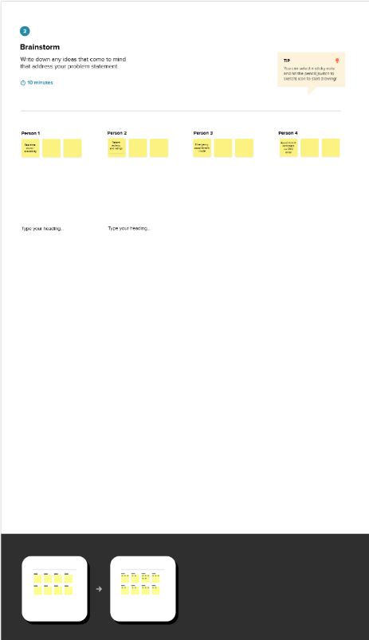rs.
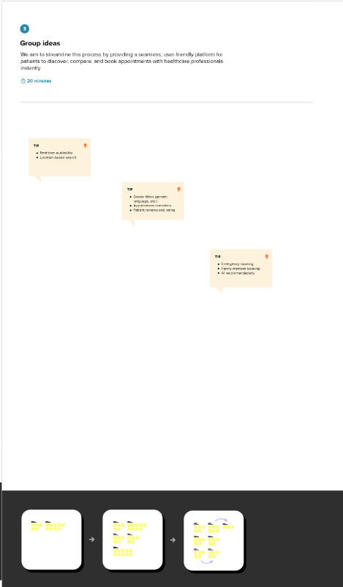

Step-3: Idea Prioritization
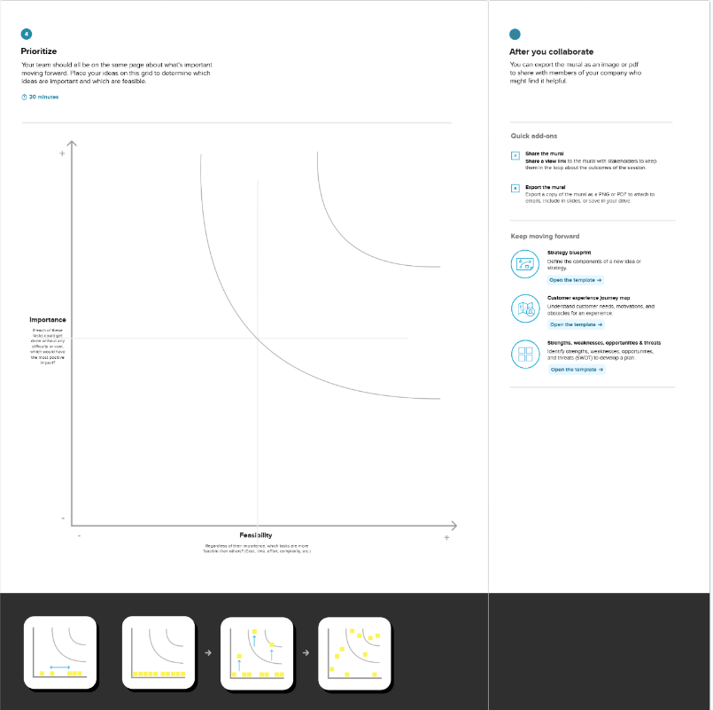
The team evaluated the proposed ideas based on criteria such as feasibility, innovation, real-world impact, and implementation complexity. The dog breed identification system using deep learning was prioritized because it offers an efficient solution for recognizing dog breeds from images, reduces manual effort, minimizes human error, and improves pet identification accuracy. The availability of pre-trained deep learning models and datasets makes the implementation feasible. Therefore, this idea was selected as the final project for development.

